RCDS user manual

# Introduction

This manual is a guidance for using *RCDS* MATLAB based executables to model 3D rice plant and canopy architecture from key plant architecture parameters, and calculate canopy light distribution and canopy gas exchange rate from leaf optical and photosynthetic properties (Fig. 1.1).

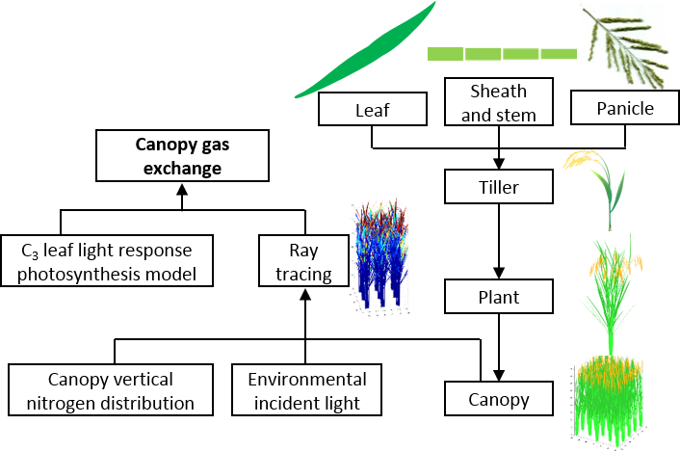

**Figure 1.1 Workflow of canopy architecture reconstruction and gas exchange prediction by RCDS.** Firstly, the 2D and 3D structure of individual organs, i.e. leaf, sheath and stem and panicle, were reconstructed. Then these organs were assembled into a tiller of a plant. Thirdly, different tillers were arranged to form a plant. A canopy could be generated by arranging plants with certain distance between plants. A forward ray tracing algorithm was applied to simulate canopy light distribution with given canopy vertical nitrogen distribution, environmental incident light and generated canopy structure in last step. Finally, instantaneous canopy gas exchange rate was calculated by adding up all single leaf gas exchange rate, which was calculated by the semi-empirical C3 leaf light response photosynthesis model, and daily accumulated net canopy assimilation could be calculated by integration of instantaneous canopy gas exchange rate at different time of day.

# Preparation

1. Full installation of MATLAB compiler runtime 9.1.

# Usage of *RCDS*

To run the RCDS, double click the run_RCDS.exe file or type in the following commands into windows DOS command window or PowerShell command window:

> .\run_RCDS.exe

then a graphic user interface (GUI) will pop up (Fig. 2.1). There are three tabs of the GUI for three major functions of the *RCDS*, they are the basic simulations (CP calculator), plant spacing and tiller number optimization (PS-TN optimizer) and plant type optimization (PT optimizer). In the following we will introduce them in detail.

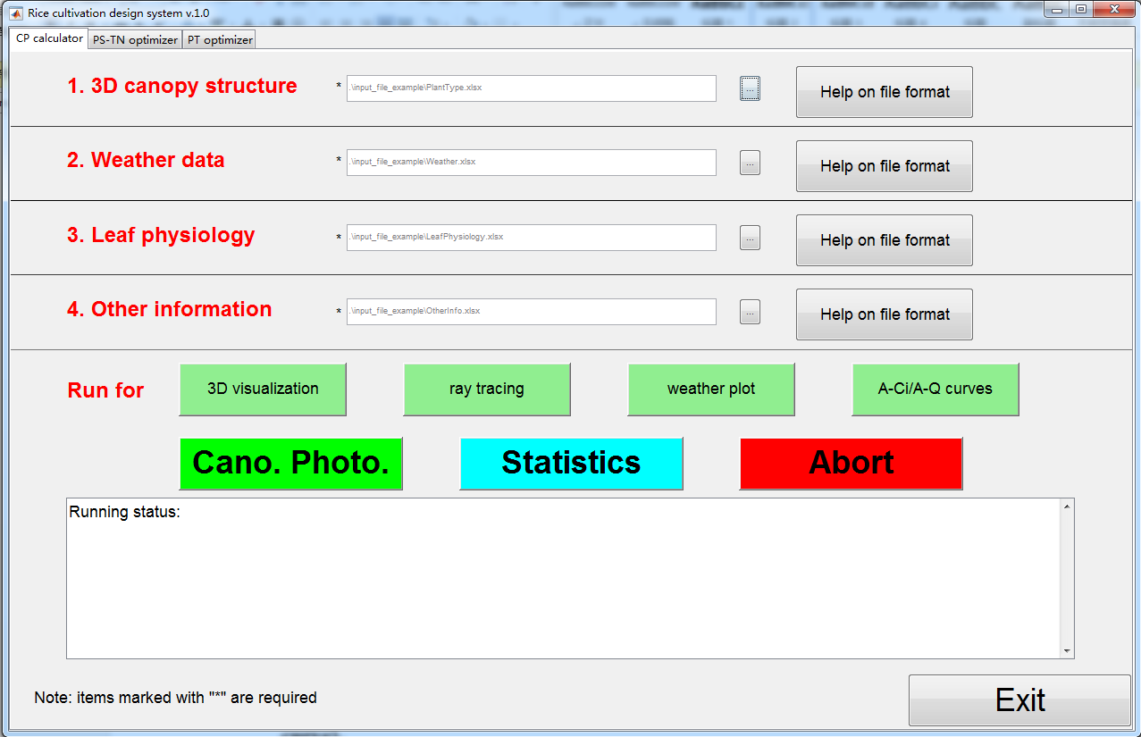

**Figure 2.1 The graphic user interface of *RCDS*.**

## CP calculator

This is the first tab on the *RCDS* GUI, from which one can perform basic simulation on canopy photosynthesis of a rice canopy with standard format input files. Basically, there are 4 input files in Excel format, covering the plant type (see a template in .\input_file_example\PlantType.xlsx), the leaf physiology (see a template in .\input_file_example\LeafPhysiology.xlsx), the weather (see a template in .\input_file_example\Weather.xlsx), and other information (see a template in .\input_file_example\OtherInfo.xlsx). Specifically, the plant type parameters can be sorted from results of *3dPlant* series programs; the relationship between leaf photosynthetic physiology VS leaf nitrogen concentration (LNC) can be obtained by fitting A-Q curve related parameters and LNC with polynomial equations (Fig. 3.1); the weather data can be obtained from weather station and etc.

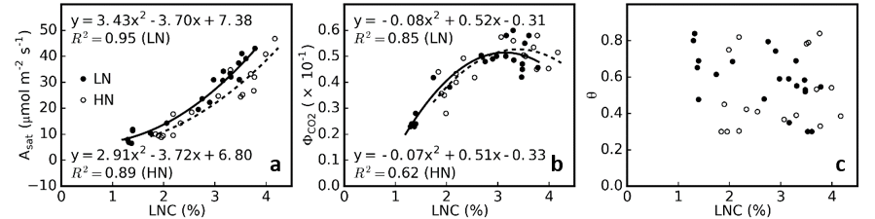

**Figure 3.1 The relationship between leaf photosynthetic characteristics and leaf nitrogen concentration.**

Before pressing any RUN button on the interface, you should first provide the 4 input files. Format of the plant structure parameters files can be found under the “.\input_file_example\” directory.

### Plot given weather data

Click ‘weather plot’ to plot and confirm the given weather data. After running, a figure showing dynamic weather information (Fig. 3.2) will pop up and be saved as “.\result_basicSimulation\runID_weather.png”, in which runID is the string given in the other information file (cell 1, sheet 1).

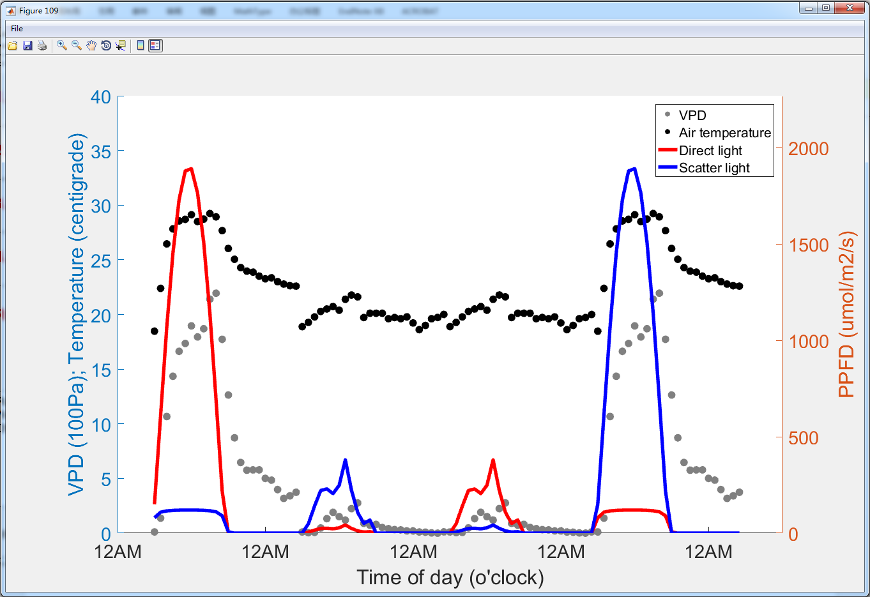

**Figure 3.2 Plot of the given weather data.** The essential weather data includes vapor pressure deficit (VPD), air temperature, direct and scatter light intensity.

### Plot leaf nitrogen concentration (LNC) VS leaf light photosynthetic response curve (A-Q curve)

Click ‘A-Ci/A-Q curves’ to plot the light response curve under different leaf nitrogen concentration with relationship of leaf photosynthetic parameters and LNC given in the leaf photosynthetic physiology file (Fig. 3.2). After running, a figure showing A-Q curves under different LNC (Fig. 3.3) will pop up and be saved as “.\result_basicSimulation\runID_AQ.png”, in which runID is the string given in the other information file (cell 1, sheet 1).

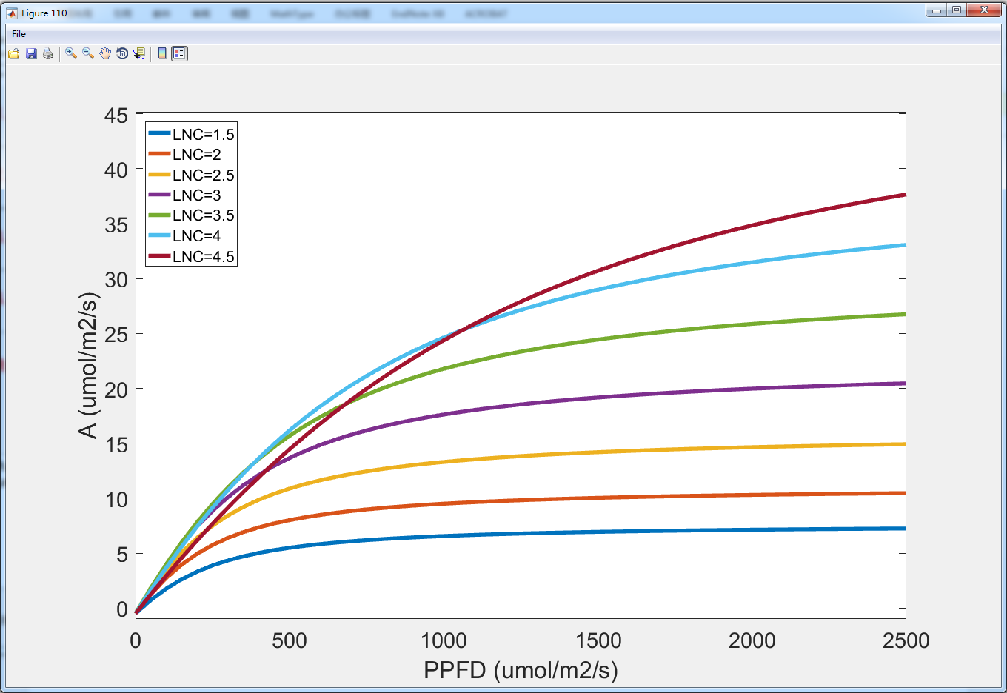

**Figure 3.3 Plot of leaf photosynthetic light response curve under different leaf nitrogen concentration.**

### Plant reconstruction

Click “3D visualization” to reconstruct the rice plant and canopy based on given plant type file. After running, figures illustrating 3D rice plant and canopy (Fig. 3.4) will pop up and be saved as “.\result_basicSimulation\runID_plant_DAF.png” and “.\result_basicSimulation\runID_canopy_DAF.png”, respectively, digital triangulation data of plant organs is stored in “.\result_basicSimulation\runID_canopy_DAF.txt”, in which runID is the string given in the other information file (cell 1, sheet 1); DAF is day after flowering marker given in the plant type file (cell 10, sheet2).

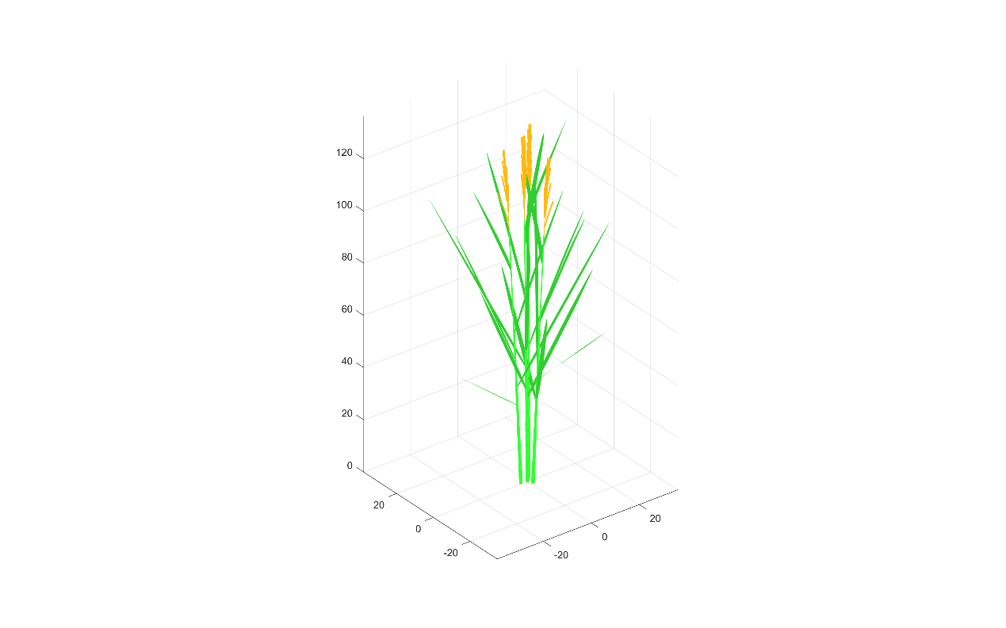 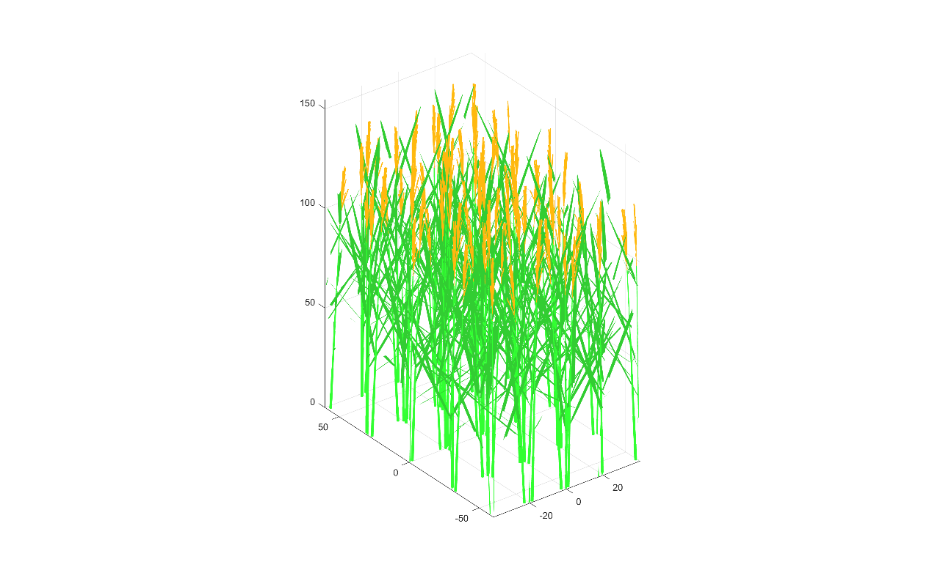

**Figure 3.4 3D plot of single rice plant (left) and a canopy (right) which will be used for ray tracing simulation.**

### Canopy ray tracing

Click “ray tracing” to simulate the hourly dynamic canopy light distribution. After running, figures reflecting light distribution within the canopy at each daily time point will be saved as “.\result_basicSimulation\rayTracingFigs\runID_canopyRay_m_d_h_m_s_DAF.png”, a video using these images as frames (Fig. 3.5) will pop up and be saved as “.\result_basicSimulation\rayTracingFigs\ruAnID_canopyLightDynamic_DAF.avi”and a data file recording plant structure and light distribution on each facet will be saved as “.\result_basicSimulation\runID_canopyRay_DAF.txt” (the name of each column is stored in file “.\result_basicSimulation\runID_canopyRay_DAF_header.txt”), in which runID is the string given in the other information file (cell 1, sheet 1); DAF is day after flowering marker given in the plant type file (cell 10, sheet2).

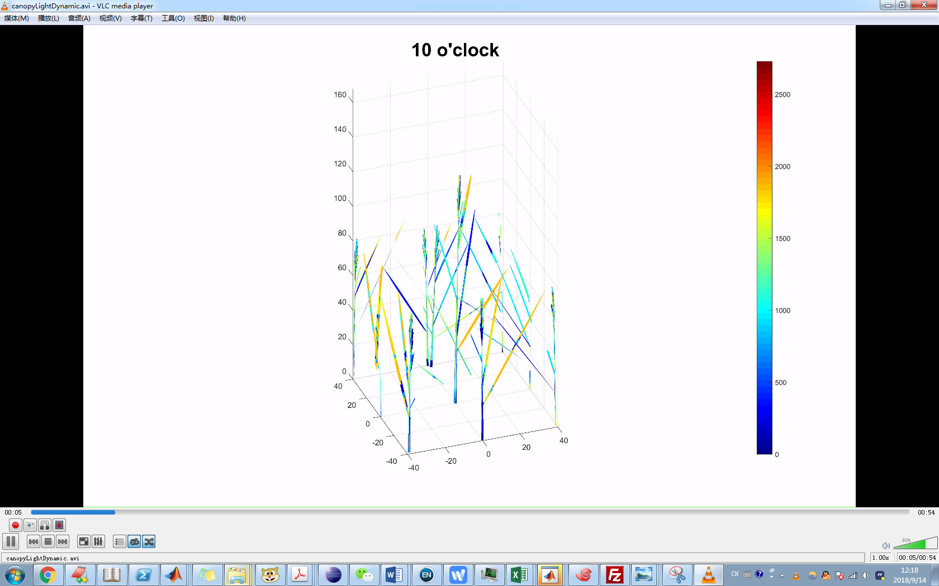

**Figure 3.5 A frame of the video displaying dynamic light distribution in the canopy with day time.**

### Hourly canopy photosynthetic rate calculation

Click “Cano. Photo.” to simulate the canopy photosynthesis across time. After running, a figure showing canopy photosynthetic rate dynamic across given time interval (Fig. 3.6 left) and versus PPFD (Fig. 3.6 right) will pop up and be saved as “.\result_basicSimulation\runID_CanopyPhotoDynamic_DAF.png”. A data file recording plant structure, light distribution and photosynthetic rate on each facet will be saved as “.\result_basicSimulation\runID_canopyPhotoRate_DAF.txt” (the name of each column is stored in file “.\result_basicSimulation\runID_canopyPhotoRate_DAF_header.txt”), in which runID is the string given in the other information file (cell 1, sheet 1); DAF is day after flowering marker given in the plant type file (cell 10, sheet2).

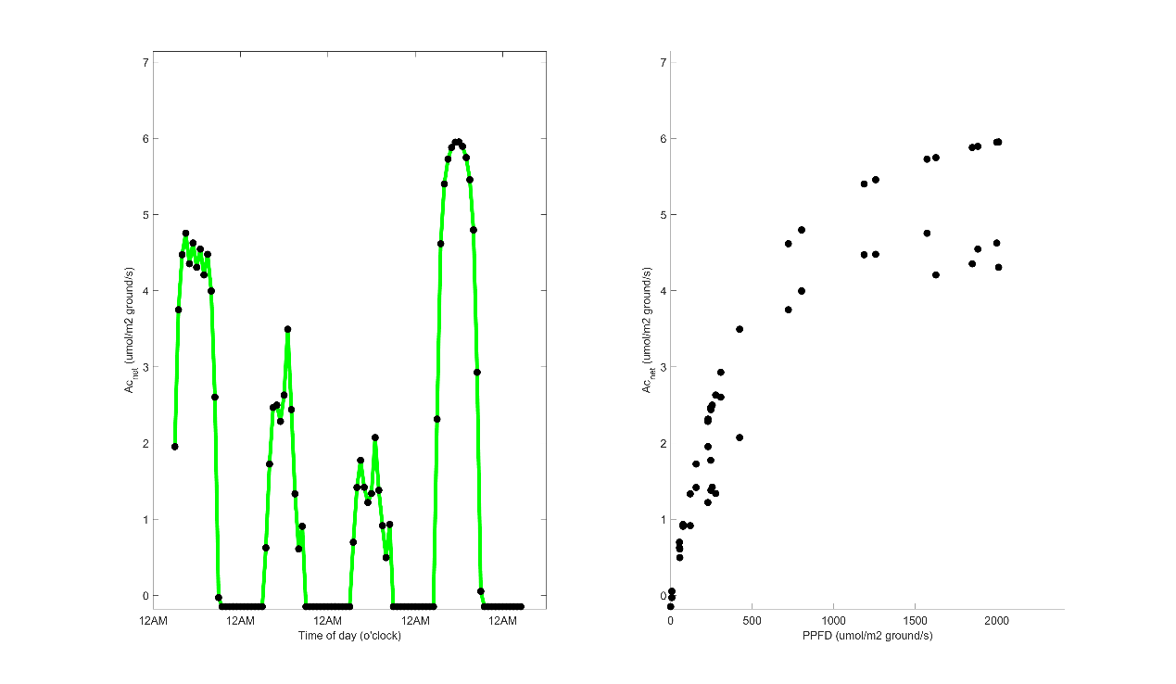

**Figure 3.6 Canopy photosynthetic rate (Acnet) dynamic across given time interval (left) and relationship between each time point Acnet and PPFD (right).**

### Statistics of canopy photosynthetic characteristics

Click “Statistics” to summary photosynthetic characteristics of current canopy. After running, a figure showing canopy photosynthetic characteristics (Fig. 3.7) will pop up and be saved as “.\result_basicSimulation\runID_CanopyPhotoFeatures_DAF.png”. Original data for generating panels of this figure will be saved as “.\result_basicSimulation\runID_organ_light_absorb_DAF.txt” (related to Fig. 3.7a), “.\result_basicSimulation\runID_leaves_light_absorb_DAF.txt” (related to Fig. 3.7b), “.\result_basicSimulation\runID_leaf_Anet_dynamic_DAF.txt” (related to Fig. 3.7d), “.\result_basicSimulation\runID_leaves_Anet_accumulated_DAF.txt” (related to Fig. 3.7e), respectively; in which runID is the string given in the other information file (cell 1, sheet 1); DAF is day after flowering marker given in the plant type file (cell 10, sheet2).

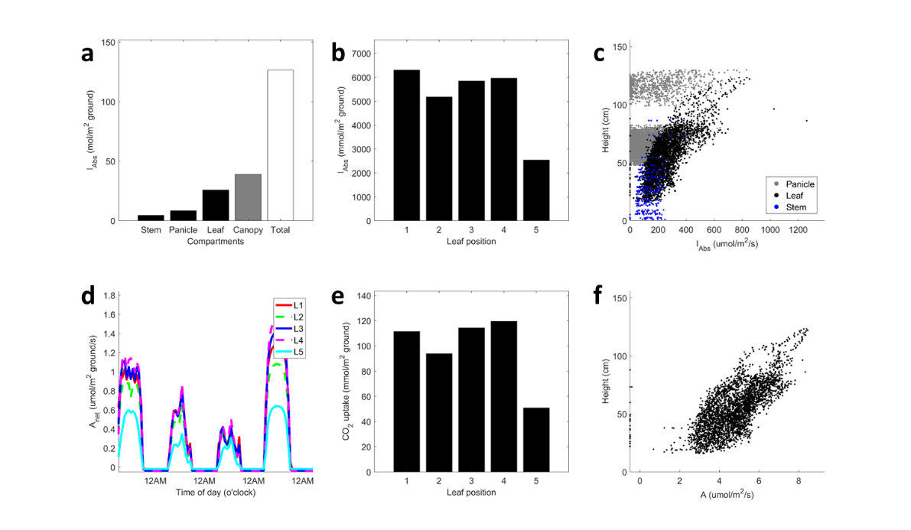

**Figure 3.7 Statistics of rice canopy photosynthesis.** a, Organ integrated light absorption for different plant organs and total incident light; b, integrated light absorption of leaves at different leaf positions (from top to bottom); c, average light intensity of plant organ facets located at different canopy height; d, dynamic photosynthetic rate of leaves at different leaf positions (from top to bottom) on a ground area basis; e, accumulated CO2 uptake of leaves at different leaf positions (from top to bottom); f, average photosynthetic rate of leaf facets located at different canopy height.

## PS-TN optimizer

This is the second tab on the *RCDS* GUI (Fig. 4.1), from which one can perform plant spacing and tiller number optimization (PS-TN optimization) for greater canopy photosynthesis of a rice canopy with standard format input files and GUI input. The 4 input files in Excel format are described in the last section (standard template of them can be found under the “.\input_file_example\” directory).

On the GUI, firstly you can set a single value for each of the 4 key parameters used in PS-TN optimization manually for one run. These parameters are planting distance between two neighboring rows (Row dist), planting distance between two neighboring columns (Col dist), tiller number of one plant (Tiller NO.), whether the square planting scheme (planting pattern=1) or the triangle planting scheme (planting pattern=2) is used (a illustration of these two patterns can be found in Fig. 4.2). Then you can check the 3D architecture of the plant/canopy and the canopy photosynthesis for this parameter combination by click “3D visualization” and “Cano. Photo.”, respectively.

You can also perform large scale simulation searching for optimal PS-TN combinations in a certain parameter range. Firstly, give the range of each parameter with a “-” between the maximal value and the minimal value. Note that only integral values are allowed for each parameter. You can also assign the core numbers (“CPUs” in Fig. 4.1) used for parallel computing. Note that the assigned core numbers should not be too high, otherwise it will not help speeding the computation but may crash your computer. This may take a long time as a result of large scale detailed simulation of canopy light distribution. After running, one or a number of heatmap figures will pop up, showing the landscape of canopy photosynthesis under different parameter combinations (Fig. 4.3). A popup menu will show the information of optimal parameter combination and maximal canopy photosynthesis (Fig. 4.4). The detailed statistics data for each parameter combination, including canopy photosynthetic accumulation, canopy photosynthetic rate of each leaf at each time point, absorbed is stored in “.\result_cultivationDesign\PS_TN_CP_result.txt” for further analysis.

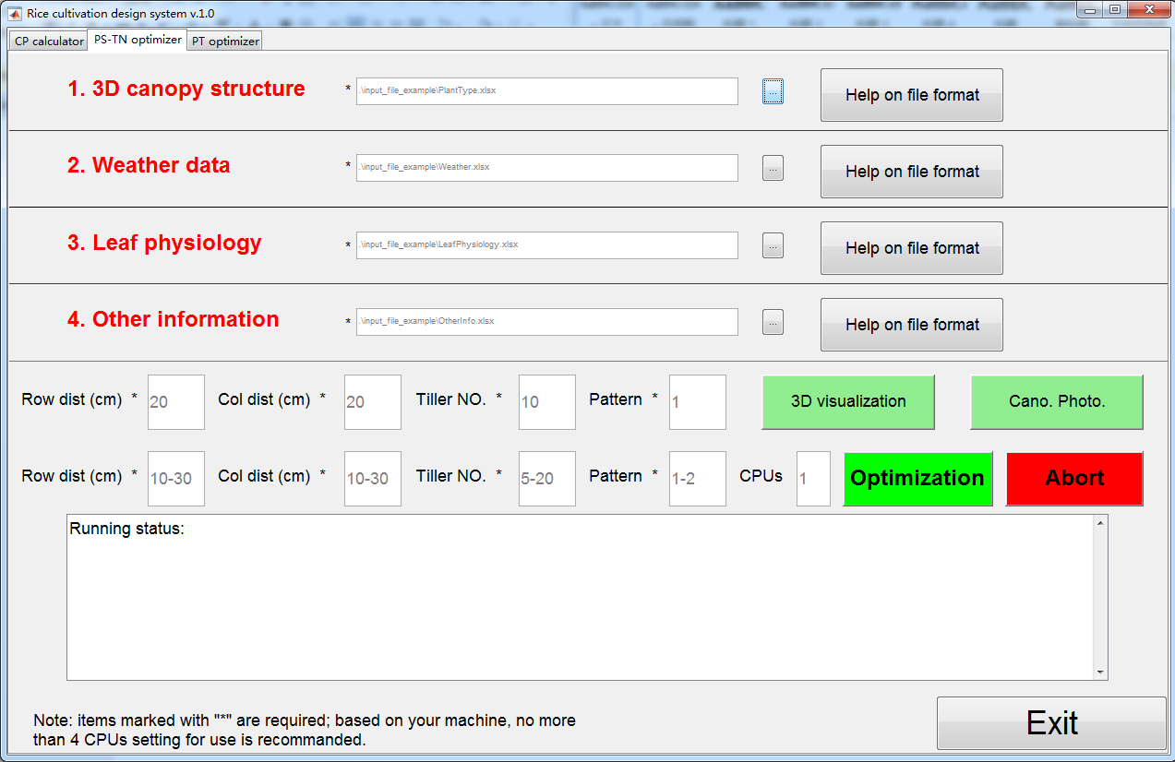

**Figure 4.1 The GUI of PS-TN optimizer.**

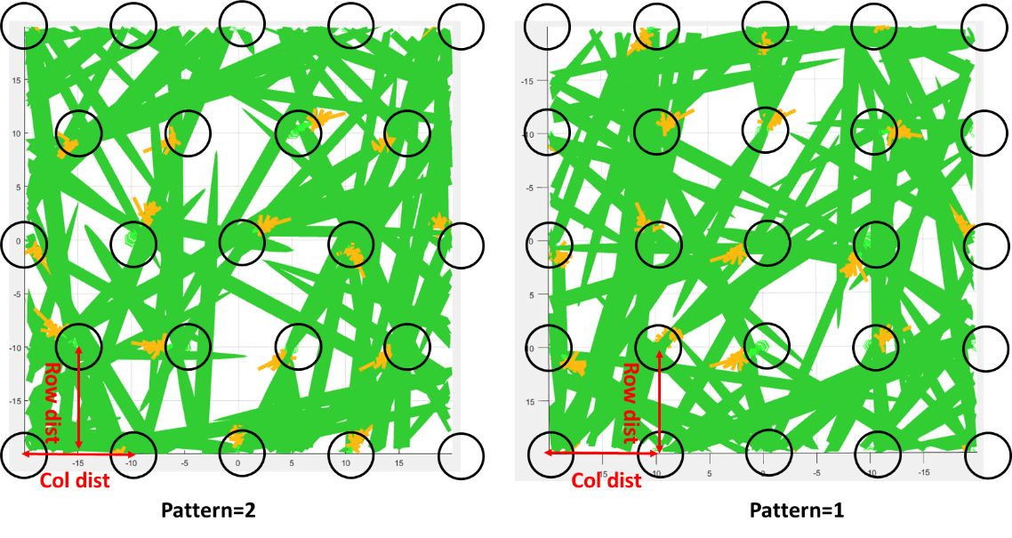

**Figure 4.2 A top-down view of two planting patterns. Note that each circle represents a plant.** Row distance and column distance of these two patterns are illustrated.

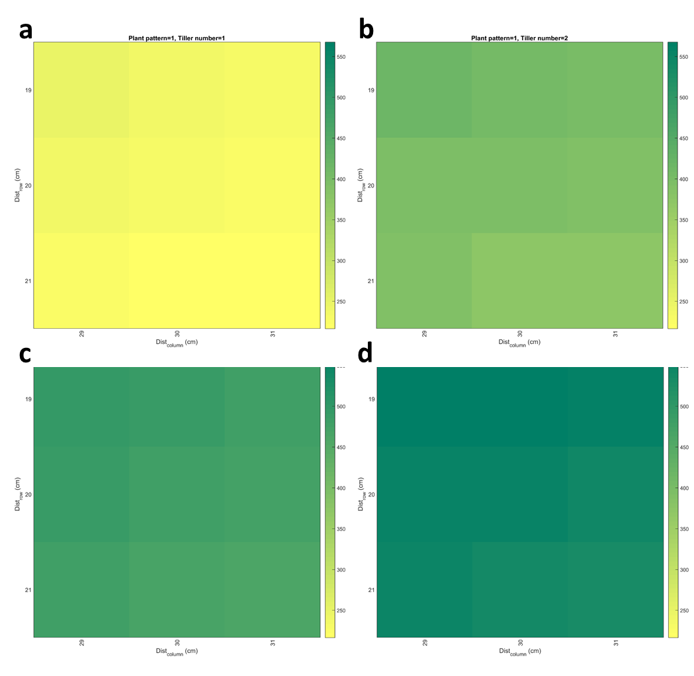

**Figure 4.3 An example of output figures showing daily canopy photosynthetic assimilation (mmol m-2) heatmap for PS-TN optimization.** Canopy photosynthesis landscape with different combinations of Row dist and Col dist when TN=1 (a), 2 (b), 3 (c) and 4 (d). In this simulation, the parameter range is given as: Tiller Number 1-4; Row dist 19-21; Col dist 29-31; Pattern 1.

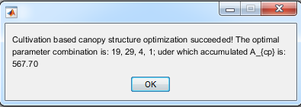

**Figure 4.4 After the PS-TN optimization run finished, a popup menu carrying the optimal parameter combination and the maximal canopy photosynthesis accumulation information will show.**

## PT optimizer

This is the third tab on the *RCDS* GUI (Fig. 4.5), from which one can perform plant type optimization (PT optimization) for greater canopy photosynthesis of a rice canopy with standard format input files and GUI input. The 4 input files in Excel format are described in the CP calculator section (standard template of them can be found under the “.\input_file_example\” directory).

On the GUI, firstly you can set a single value for each of the 5 key parameters used in PT optimization manually for one run. These parameters are tiller number of one plant (TN), tiller angle between two neighboring layer tillers (TA, degree), leaf based angle relative to default values given in plant type file (LA, fold), leaf area index (LAI) and plant height (PH, cm). Then you can check the 3D architecture of the plant/canopy and the canopy photosynthesis for this parameter combination by click “3D visualization” and “Cano. Photo.”, respectively.

You can also perform large scale simulation searching for optimal PT combinations in a certain parameter range. Firstly, give the range of each parameter with a “-” between the maximal value and the minimal value. Note that only integral values are allowed for parameter “TN”, “TA” and “PH”, and the precision for “LA” is 0.05, for “LAI” is 0.1. You can also assign the core numbers (“CPUs” in Fig. 4.5) used for parallel computing. Note that the assigned core numbers should not be too high, otherwise it will not help speeding the computation but may crash your computer. This may take a long time as a result of large scale detailed simulation of canopy light distribution. After running, one or a number of heatmap figures will pop up, showing the landscape of canopy photosynthesis under different parameter combinations (Fig. 4.6). A popup menu will show the information of optimal parameter combination and maximal canopy photosynthesis (Fig. 4.7). The detailed statistics data for each parameter combination, including canopy photosynthetic accumulation, canopy photosynthetic rate of each leaf at each time point, absorbed is stored in “.\result_plantTypeDesign\PT_CP_result.txt” for further analysis.

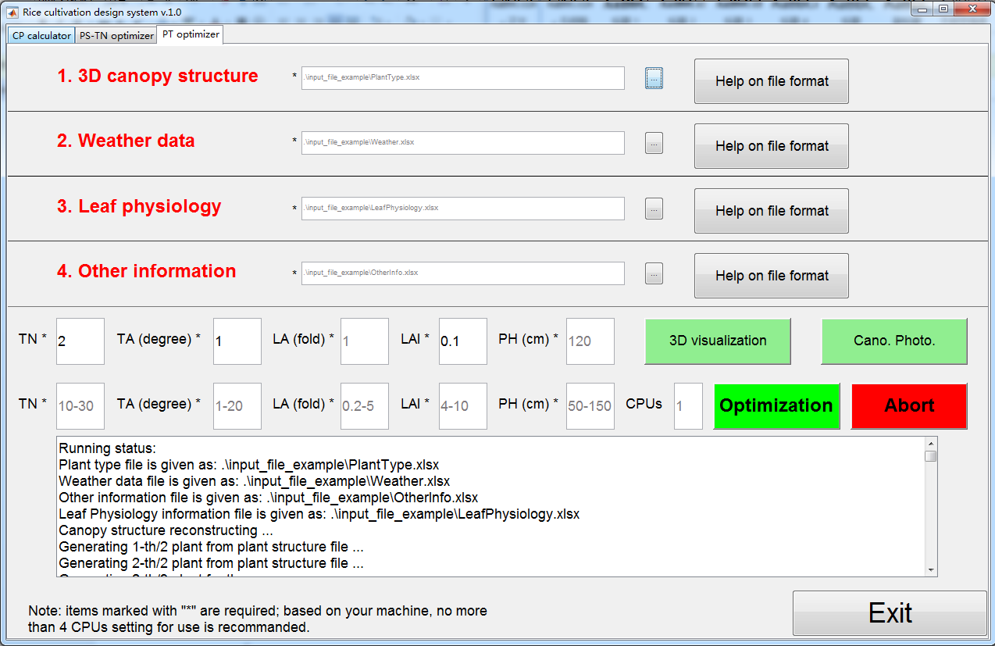

**Figure 4.5 The GUI of PT optimizer.**

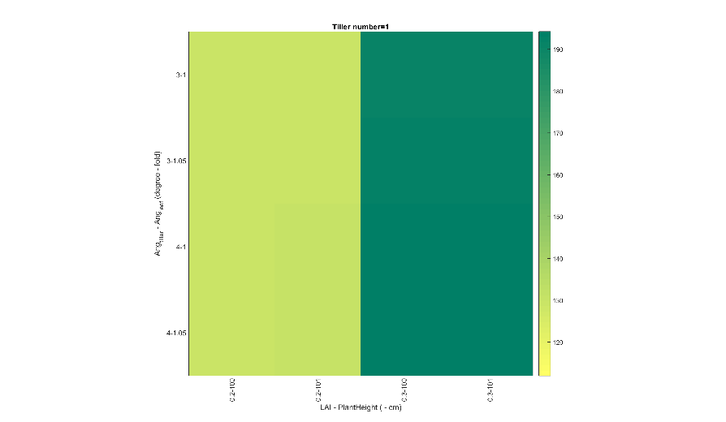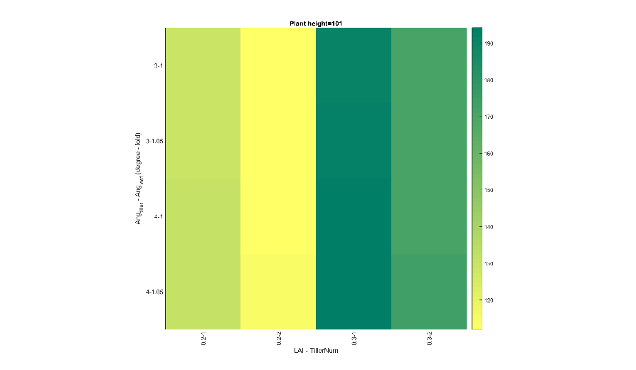

**Figure 4.6 Two representative figures from a case in running PT optimization.** Left, canopy photosynthesis landscape with different combinations of LAI-PH and TA-LA when TN is fixed (for this figure TN=1). Right, canopy photosynthesis landscape with different combinations of LAI-TN and TA-LA when PH is fixed (for this figure PH=101). In this simulation, the parameter range is given as: TN 1-2; TA 3-4; LA 1-1.05; LAI 0.2-0.3; PH 100-101.

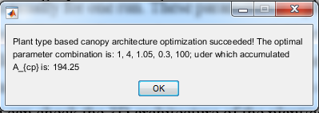

**Figure 4.7 After the PT optimization run finished, a popup menu carrying the optimal parameter combination and the maximal canopy photosynthesis accumulation information will show.**

Welcome to use these tools. Any bug is welcomed to report to [1664059681@qq.com](mailto:1664059681@qq.com).

© 2014-2018 Tiangen Chang All Rights Reserved